Grayerville area by overseeing the generation to closing of deals Maintained a 100% client satisfaction rating and generated 10% growth in annual revenue by working closely with sales and support teams
Opened five new accounts by providing prompt, consistent, quality customer service

Field Sales Executive Errandeo Services
Nov 2021 - Jan 2023 (1 year, 2 months) Increased customer loyalty by 40% within six months by managing key accounts in Fairhill and serving as a
coordinator with the operations team Achieved a 5% growth in our client base by finding opportunities for partnership with various companies
Boosted customer satisfaction by 10% by introducing a feedback check-in after three months of a sale

EDUCATION HISTORY

Bachelor of Science in Business Administration, Major in Supply Chain Management
University of Roseton
2020
Cum Laude
President, Roseton Debate Club

Nellie Iglesias
Sales Executive

Portfolio Link

CONTACT ME
linkedin.com/in/name

hello@reallygreatsite.com
+123-456-7890
www.reallygreatsite.com

RELEVANT SKILLS

Account Management Customer Relationship Management Software Strategic and Social Selling


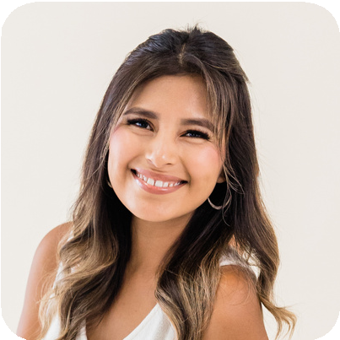

VOLUNTEER WORK AND CERTIFICATES

Volunteer English Teacher
Lily River Children's Foundation

Awardee
Inbound Sales and Marketing Certificate

Grayerville area by overseeing the
generation to Maintained a rating and ge annual revenu sales and sup Opened five n prompt, consi service

Tip: Add a company logo for brand recognition. Link its website or profile to its name. You may also add a short description of what the company does.
closing of deals
100% client satisfaction nerated 10% growth in
e by working closely with port teams
ew accounts by providing stent, quality customer

Nellie Iglesias
Sales Executive

Field Sales Executive Errandeo Services
Nov 2021 - Jan 2023 (1 year, 2 months) Increased customer loyalty by 40% within six months by managing key accounts in Fairhill and serving as a
coordinator with the operations team Achieved a 5% growth in our client base by finding opportunities for partnership with various companies
Boosted customer satisfaction by 10% by introducing a feedback check-in after three months of a sale

Portfolio Link

CONTACT ME
linkedin.com/in/name
h Tip: Don't forget to add a link to
ello@reallygreatsite.com 123-456-7890
ww.reallygreatsite.com
+ your LinkedIn account and

EDUCATION HISTORY

Bachelor of Science in Business Administration, Major in Supply Chain Management
University of Roseton
2020
Cum Laude
President, Roseton Debate Club
w portfolio site.

RELEVANT SKILLS
Account Management
Customer Relationship Management Software Strategic and Social Selling

Tip: Only include skills that are relevant to the job. You may also list specific software or tools that are important to the role.



VOLUNTEER WORK AND CERTIFICATES

Volunteer English Teacher

Important: Download your CV as a PDF. Do not use docx, png, or jpg since an applicant tracking system may not be able to properly display the file or scan the text.
Lily River Children's Foundation

Tip: Listing your interests and other information is optional.

ing Certificate
Awardee
Inbound Sales and Market

